# VBA notes

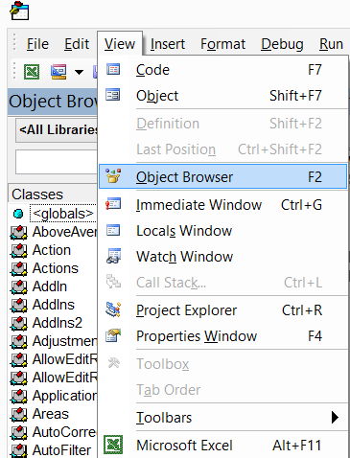

Add to the IDE

* Object Browser 🡪 F2
* "Immediate Window" 🡪 Ctrl +G
* Properties Window 🡪 F4

--================================================================================

<http://www.youtube.com/playlist?list=PLS7iHfqXNVhK3yzd_4XS5k4zsvnu2mkJC>

Code is available here:

<http://www.yourprogrammingnetwork.co.uk/>

# Tutorial 01 - Creating a Macro with Visual Basic For Applications

<https://www.youtube.com/watch?v=ABXPb0qnKUY&index=1&list=PLS7iHfqXNVhK3yzd_4XS5k4zsvnu2mkJC>

**ALT + F11** 🡪 open VBA IDE

**ALT + F8** 🡪 Select and Run a macro

**To create a VBA code:**

1. Press Alt+F11
2. Add a Module to your VBA project
3. Print Sub <SubName()>
4. Code
5. End Sub

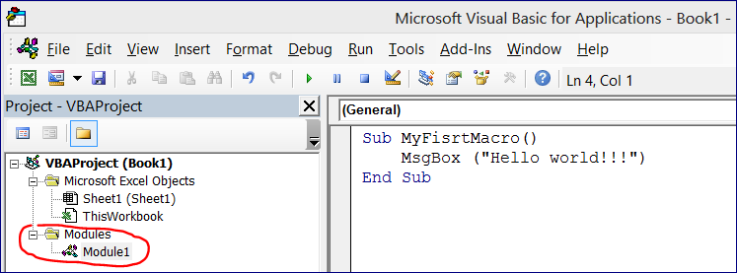

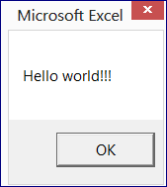

Sub Lesson001_MessageBox()

REM "Option Explicit" forces to drfine variables

'The program print out the "Hello"message

MsgBox("Hello world!!!")

End Sub

# Tutorial 02 - Referencing Ranges

REM https://www.youtube.com/watch?v=DOV4r3n3sJc&index=2&list=PLS7iHfqXNVhK3yzd_4XS5k4zsvnu2mkJC

REM "Range" allows to reference a single cell or range

Sub Lesson002_ReferencingRanges()

ThisWorkbook.Sheets("Sheet1").Range("A1").Value = "String in the cell A1"

'---------------------------------------

'Assign to E1 the value of A1

ThisWorkbook.Sheets("Sheet1").Range("E1").Value = ThisWorkbook.Sheets("Sheet1").Range("A1").Value

'---------------------------------------

'Using a variable

Dim x1 As String

Dim string1 As String

x1 = "B2"

string1 = "Assign a value using a variable"

ThisWorkbook.Sheets("Sheet1").Range(x1).Value = string1

'---------------------------------------

'Assign a value to the range

ThisWorkbook.Sheets("Sheet1").Range("C1:D10").Value = 17

'---------------------------------------

'Add a value on ANOTHER sheet

ThisWorkbook.Sheets("ExtraSheet").Range("B4").Value = "Hello Kitty"

End Sub

# Tutorial 03 - Referencing with Cells

REM https://www.youtube.com/watch?v=Dh9yQRSXp9o&index=3&list=PLS7iHfqXNVhK3yzd_4XS5k4zsvnu2mkJC

Sub Lesson003_ReferencingWithCells()

'Referencing with cells

'Cells(r,c): where r - row, c - column

ThisWorkbook.Sheets("Sheet1").Cells(5, 1).Value = 27

x = 2 'using a variable for row

ThisWorkbook.Sheets("Sheet1").Cells(x, 1).Value = 6

'Adding value to the same cell

ThisWorkbook.Sheets("Sheet1").Cells(6, 1).Value = ThisWorkbook.Sheets("Sheet1").Cells(6, 1).Value + 1

End Sub

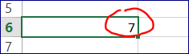

# Tutorial 04 – Hiding (Showing) Rows and Columns

We can Hide and Show row and Columns.

Works the same way as “Hide” / “Unhide” commands

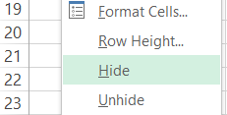

REM https://www.youtube.com/watch?v=GMtM9SxXjjg&list=PLS7iHfqXNVhK3yzd_4XS5k4zsvnu2mkJC&index=4

Sub Lesson004_HideShowRowsColumns()

Worksheets("Sheet1").Activate()

Rows("2:5").Hidden = True

Columns("B:C").Hidden = True

Worksheets("Sheet1").Activate()

'Rows("2:3").Hidden = False

'Columns("B:C").Hidden = False

Rows.Hidden = False 'unhide **all** rows

Columns.Hidden = False 'unhide **all** columns

End Sub

# Tutorial 05 - Referencing Selections

REM https://www.youtube.com/watch?v=GMtM9SxXjjg&list=PLS7iHfqXNVhK3yzd_4XS5k4zsvnu2mkJC&index=4

Sub Lesson005_FillSelection()

'Make operations with selections

'(1) Select a range on the sheet, (2) Run the macro

Selection.Value = "Filled"

Selection.Interior.Color = RGB(0, 50, 0)

Selection.Font.Color = RGB(255, 255, 255)

Selection.Font.Bold = True

End Sub

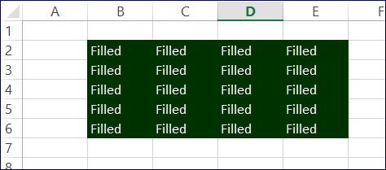

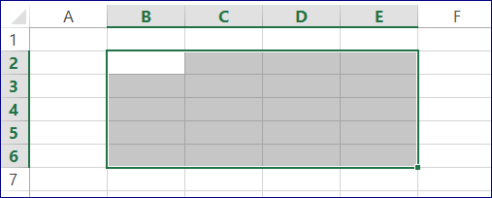

# Tutorial 06 - Variables

REM https://www.youtube.com/watch?v=7fhVnl3AaTc&index=6&list=PLS7iHfqXNVhK3yzd_4XS5k4zsvnu2mkJC

Sub Lesson006_UserInput()

**'Declare variables**

Dim num1 As Integer

Dim num2 As Integer

Dim num3 As Integer

num1 = InputBox("Input your FIRST number")

num2 = InputBox("Input your SECOND number")

num3 = num1 + num2

**'Use "&" to concatenate strings**

MsgBox("Sum of First and Second numbers = " **&** num3)

End Sub

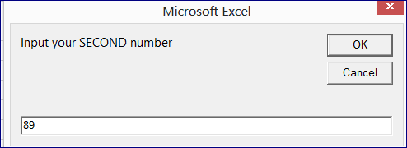

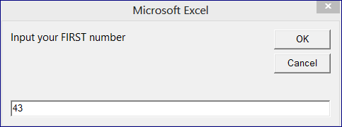

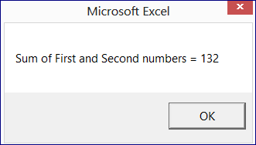

# Tutorial 07 - Numerical Operations and Decimal Points

Sub Lesson07_UserInput2()

'Declare variables

Dim num1 As Double

Dim num2 As Double

Dim num3 As Double

num1 = InputBox("Input your FIRST number")

num2 = InputBox("Input your SECOND number")

num3 = num1 / num2

'Use "&" to concatenate strings

MsgBox("Devision First Num / Second Num = " & num3)

End Sub